**User Interface Design Guidelines**

Assignment 3

**COMSATS University Islamabad**

Sahiwal Campus



**Usama Sarwar**

FA17-BS(CS)-090-B

**Mr. Awais**

Human Computer Interaction

December 8, 2020

Table of Contents

1. Smart Notifications I

2. Designing Notifications II

2.1 Web Push, Chrome for macOS Big Sur III

2.2 Web Push, Firefox for macOS Big Sur V

2.3 Web Push, Safari for macOS Big Sur VI

2.4 Web Push, Chrome for macOS Catalina VII

2.5 Web Push, Firefox for macOS Catalina VIII

2.6 Web Push, Safari for macOS Catalina IX

2.7 Web Push, Chrome for Windows 10 X

2.8 Web Push, Firefox for Windows 10 XI

2.9 Web Push, Microsoft Edge for Windows 10 XII

2.10 Web Push, Chrome for Android 11 XIII

2.11 Mobile Push, Android 11 Native XIV

2.12 Mobile Push, iOS 14 Native XV

List of Figures

Figure 1. Chrome push notification for macOS Big Sur III

Figure 2. Firefox push notification for macOS Big Sur V

Figure 3. Safari push notification for macOS Big Sur VI

Figure 4. Chrome push notification for macOS Catalina VII

Figure 5. Firefox push notification for macOS VIII

Figure 6. Safari push notification for macOS IX

Figure 7. Chrome push notification for Windows X

Figure 8. Firefox push notification for Windows XI

Figure 9. Edge push notification for Windows XII

Figure 10. Chrome push notification for Android XIII

Figure 11. Native push notification for Android XIV

Figure 12. Native push notification for iOS XV

Notification Design

# Smart Notifications

Smart Notifications are a relatively new concept used to describe the various techniques designed to make Realtime, push-style messaging (such as push notifications) more relevant, useful, and appropriate for individual users.

The concept involves designing a notification or messaging system in such a way as to:

* Reduce message clutter and avoid information overload, as in the case of blind duplicates of the same notification across multiple personal devices (e.g., mobile, tablet, desktop).
* Improve the chances of a notification being received well and in context. In other words, it is personalized to the user's habits, location, time zone, and other factors that may influence whether the user appreciates the notification or not.
* Enable the user to take immediate action in flow with the idea of Realtime notifications, rather than dismiss the notification until later.

In essence, Smart Notifications aims to unify and make coherent all the Realtime communications that a user is exposed to in their typical day-to-day.

The actual techniques used to do this will necessarily vary in implementation, but a brief example might be by using a user's presence information to intelligently deliver a notification only to the device that the user is currently using, despite that they may be subscribed to the same notification channel on all their devices.

# Designing Notifications

Push notifications have been around for over 10 years. First introduced in 2009 for iOS, they quickly rolled out across all the major mobile operating systems. Then in 2014 web push came along. As of today, push notifications are supported across Apple iOS, Google Android, Huawei Android, Amazon Echo, macOS, Windows, Chrome, Safari, Firefox, Edge... the list goes on. Unfortunately, each platform is a little bit different.

It can be daunting and complicated to get your head around what exactly goes into a push notification:

* How many lines of text do you need?
* How many images?
* What are the character restrictions?
* What does it look like on the other operating systems you don’t have access to?

Here I’ll share some insights to help you navigate the design of a notification by dissecting the anatomy.

## Web Push, Chrome for macOS Big Sur

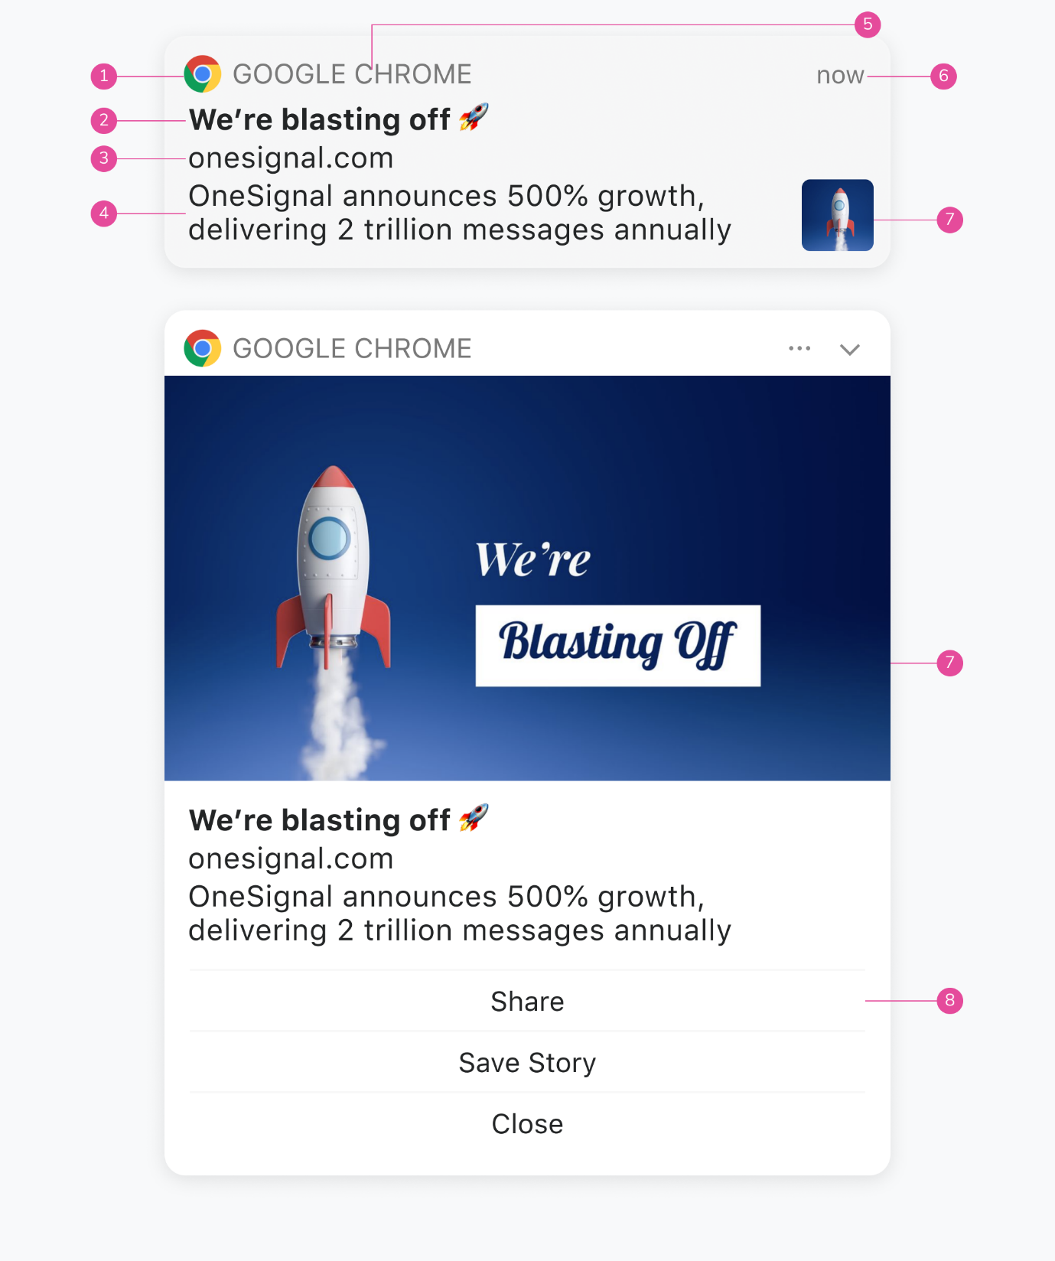

Figure 1. Chrome push notification for macOS Big Sur

**Browser Icon**  
Chrome icon. This can’t be changed.

1. **Title**  
   Restricted to 60-80 characters.
2. **Domain**  
   Website user is subscribed to. Can’t be changed.
3. **Content**  
   Restricted to 120-150 characters.
4. **Browser**  
   Can’t be changed.
5. **Time Stamp**  
   When the message was received.
6. **Icon**  
   192x192 or larger. PNG, JPG, GIF (not animated). Enlarges when expanded.
7. **Action Buttons**  
   Supports up to 2 buttons.

Note that character restrictions vary depending on if an icon is present and the characters used. The main differences between macOS Big Sur and it's predecessors is that messages can be expanded with a larger icon and the browser icon is smaller allowing more room for content.

## Web Push, Firefox for macOS Big Sur

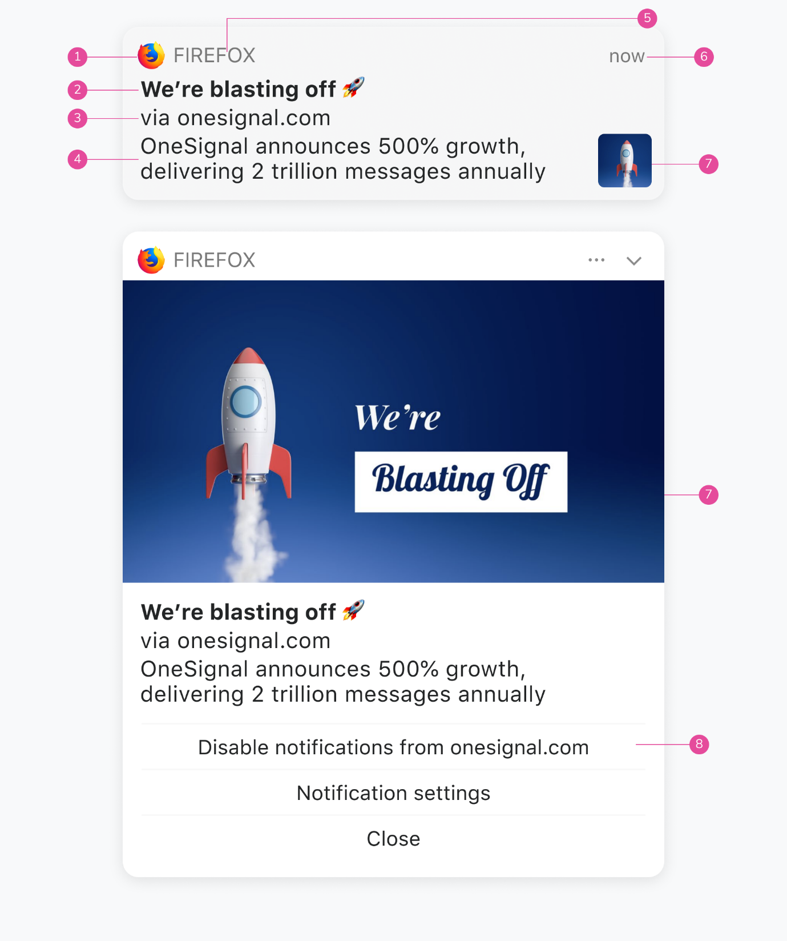

Figure 2. Firefox push notification for macOS Big Sur

**Browser Icon**  
Firefox icon. This can’t be changed.

1. **Title**  
   Restricted to 60-80 characters.
2. **Domain**  
   Website user is subscribed to. Can’t be changed.
3. **Content**  
   Restricted to 120-150 characters.
4. **Browser**  
   Can’t be changed.
5. **Time Stamp**  
   When the message was received.
6. **Icon**  
   192x192 or larger. PNG, JPG, GIF (not animated). Enlarges when expanded.
7. **Action Buttons**  
   These cannot be customized for Firefox.

Note that character restrictions vary depending on if an icon is present and the characters used. The main differences between macOS Big Sur and it's predecessors is that messages can be expanded with a larger icon and the browser icon is smaller allowing more room for content.

## Web Push, Safari for macOS Big Sur

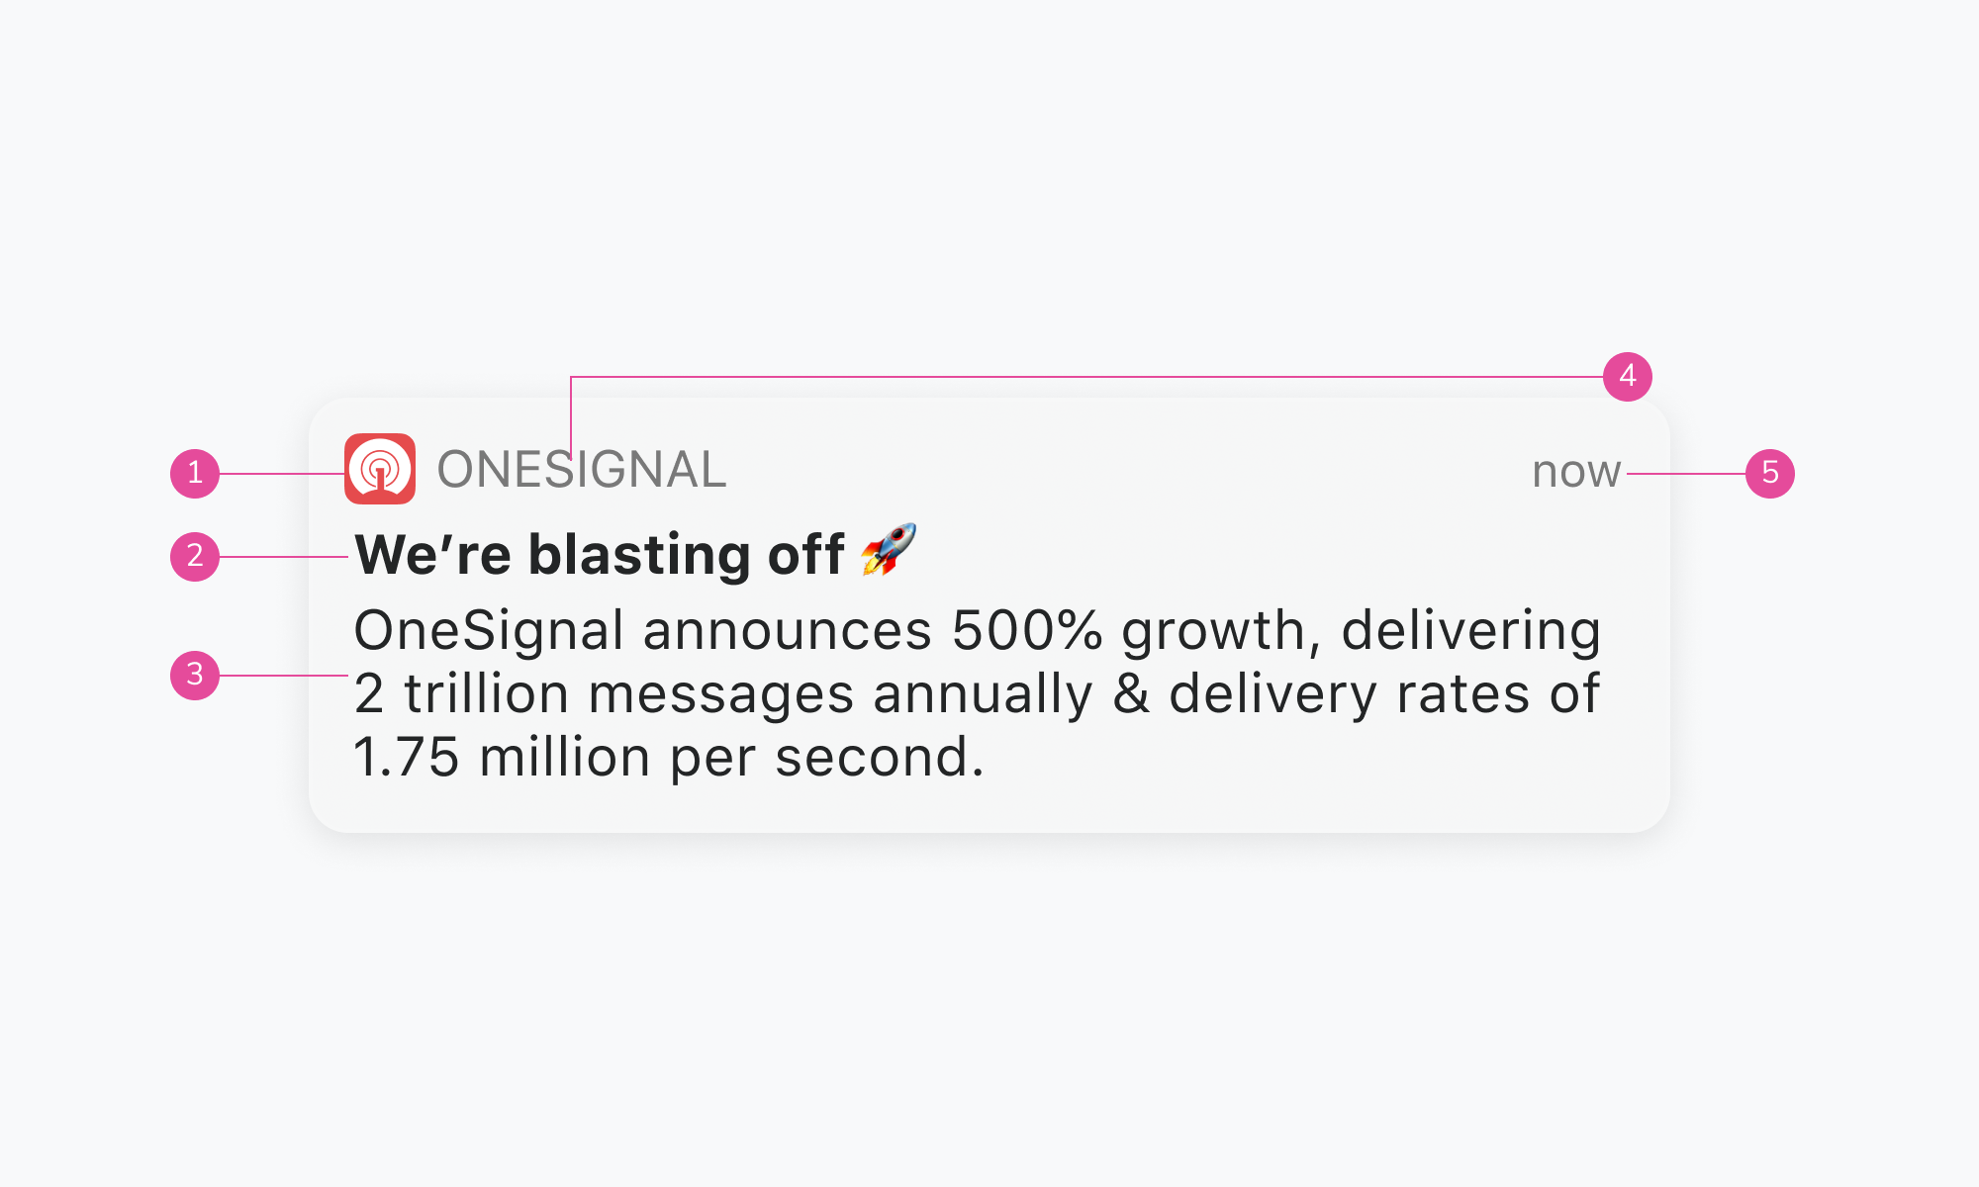

Figure 3. Safari push notification for macOS Big Sur

**Icon**  
This is set once and can’t be changed per individual message. Must be 256x256. PNG, JPG, GIF (not animated).

1. **Title**  
   Restricted to 60-80 characters.
2. **Content**  
   Restricted to 120-150 characters.
3. **Website Name**  
   Can't be changed.
4. **Time Stamp**  
   When the message was received.

## Web Push, Chrome for macOS Catalina

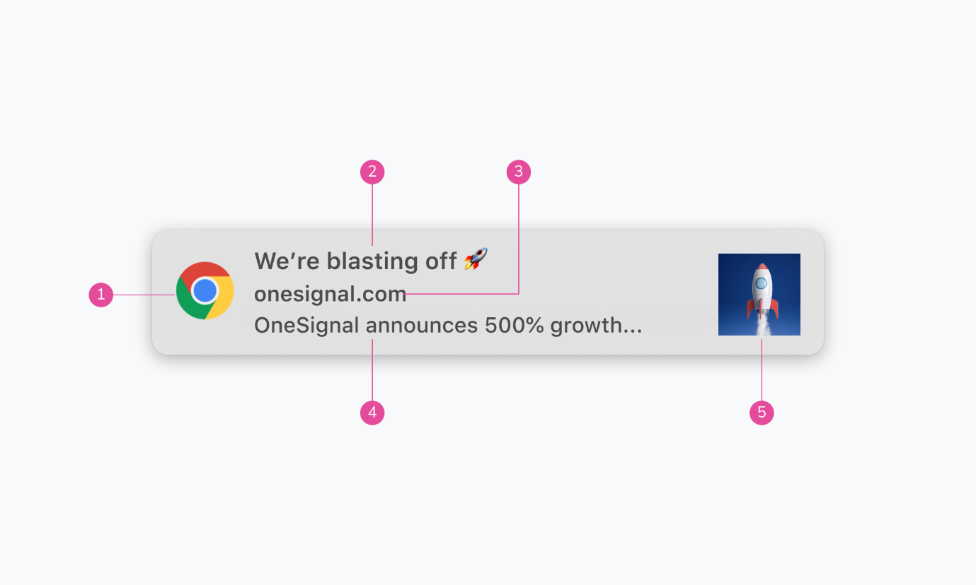

Figure 4. Chrome push notification for macOS Catalina

**Browser Icon**  
Chrome icon. This can’t be changed.

1. **Title**  
   Restricted to 20-40 characters.
2. **Domain**  
   Website user is subscribed to. Can’t be changed.
3. **Content**  
   Restricted to 20-80 characters.
4. **Icon**  
   192x192 or larger. PNG, JPG, GIF (not animated).

Note that character restrictions vary depending on if an icon is present and the characters used. Chrome for macOS also has support for 2 action buttons.

## Web Push, Firefox for macOS Catalina

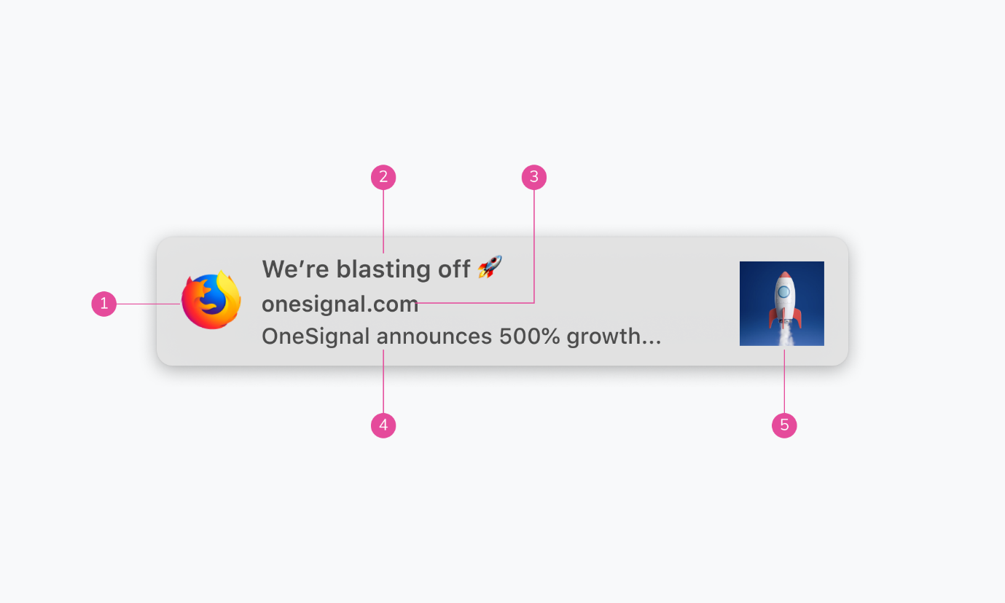

Figure 5. Firefox push notification for macOS

**Browser Icon**  
Firefox icon. This can’t be changed.

1. **Title**  
   Restricted to 60-80 characters.
2. **Domain**  
   Website user is subscribed to. Can’t be changed.
3. **Content**  
   Restricted to 20-80 characters.
4. **Icon**  
   192x192 or larger. PNG, JPG, GIF (not animated).

Note that character restrictions vary depending on if an icon is present and the characters used.

## Web Push, Safari for macOS Catalina

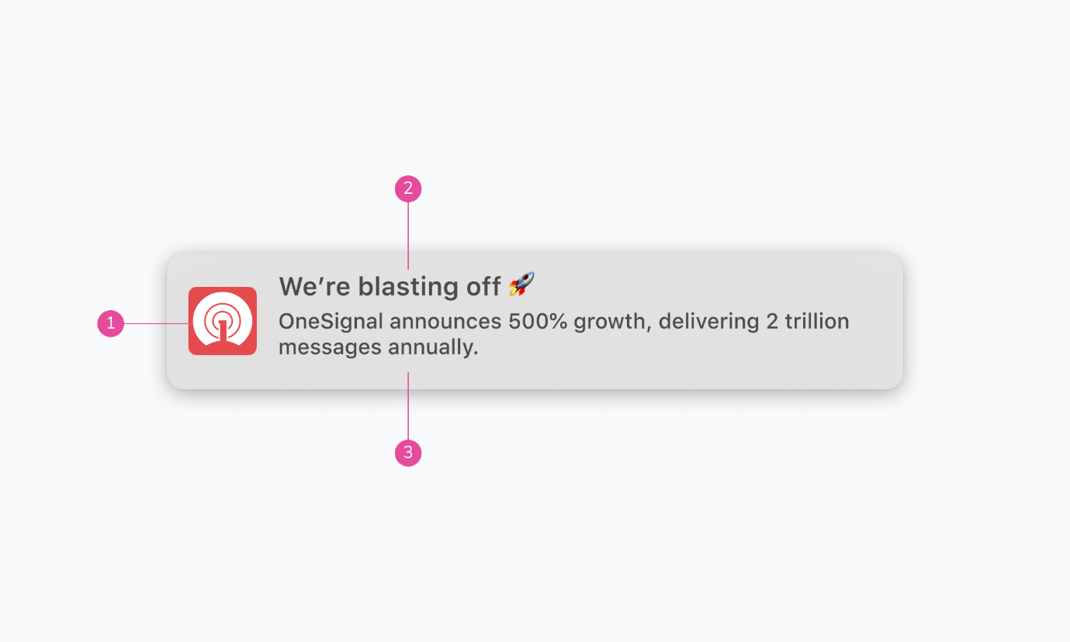

Figure 6. Safari push notification for macOS

**Icon**  
This is set once and can’t be changed per individual message. Must be 256x256. PNG, JPG, GIF (not animated).

1. **Title**  
   Restricted to 40 characters.
2. **Content**  
   Restricted to 90 characters.

Notice how Safari doesn’t have a browser icon. Nor does it display the domain.

## Web Push, Chrome for Windows 10

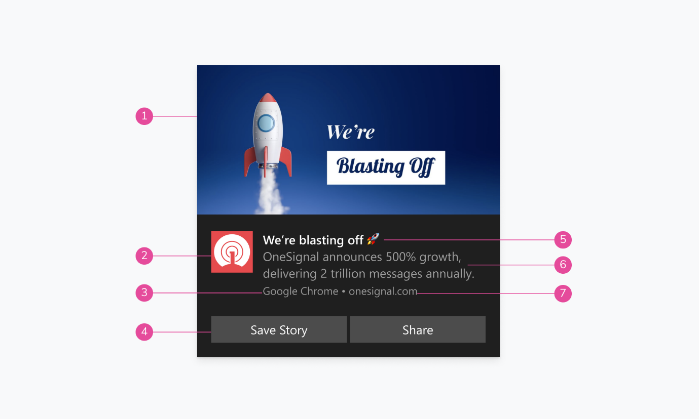

Figure 7. Chrome push notification for Windows

**Banner Image**  
360x180 or 2:1 aspect ratio. PNG, JPG, GIF (not animated).

1. **Icon**  
   192x192 or larger. PNG, JPG, GIF (not animated).
2. **Browser**  
   Can’t be changed.
3. **Action Buttons**  
   Supports up to 2 buttons.
4. **Title**  
   Restricted to 60 characters.
5. **Content**  
   Restricted to 120 characters.
6. **Domain**  
   Website user is subscribed to. Can’t be changed.

Windows offers the most screen real estate for imagery, with both the banner image and icon on display.

## Web Push, Firefox for Windows 10

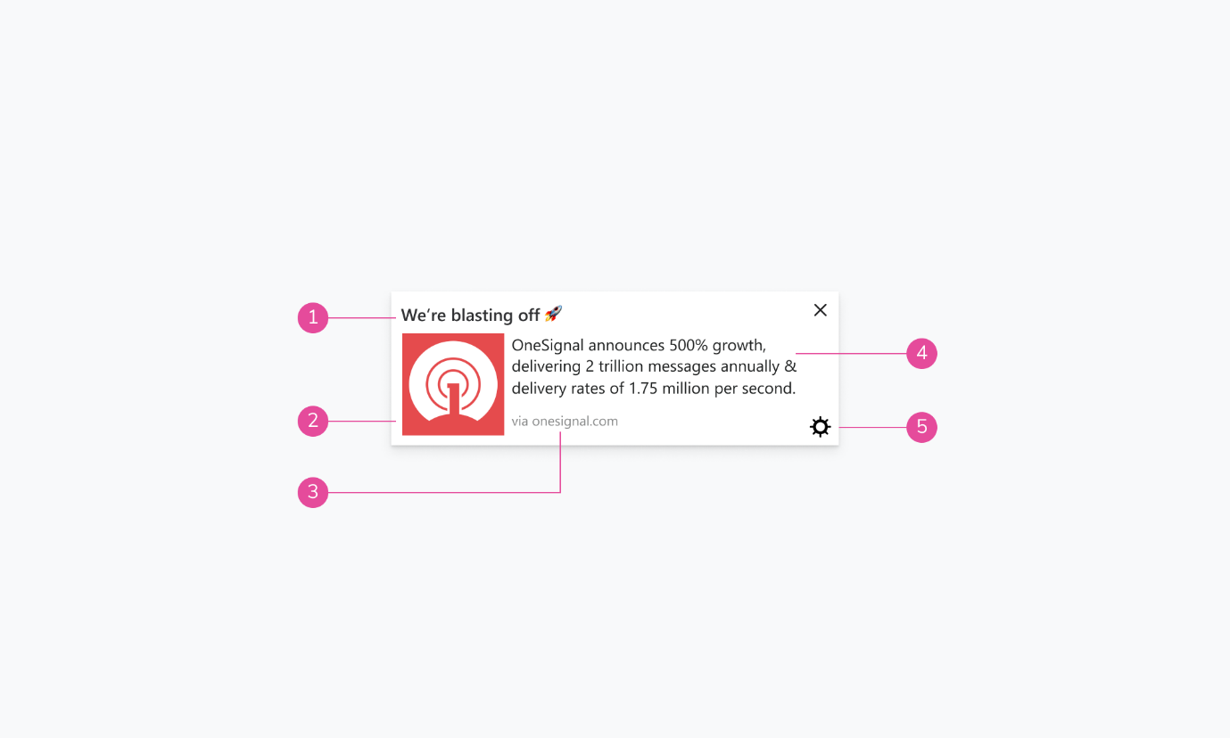

Figure 8. Firefox push notification for Windows

**Title**  
Restricted to 40 characters.

1. **Icon**  
   192x192 or larger. PNG, JPG, GIF (not animated).
2. **Domain**  
   Website user is subscribed to. Can’t be changed.
3. **Content**  
   Restricted to 140-190 characters.
4. **Settings**  
   Can’t be changed.

## Web Push, Microsoft Edge for Windows 10

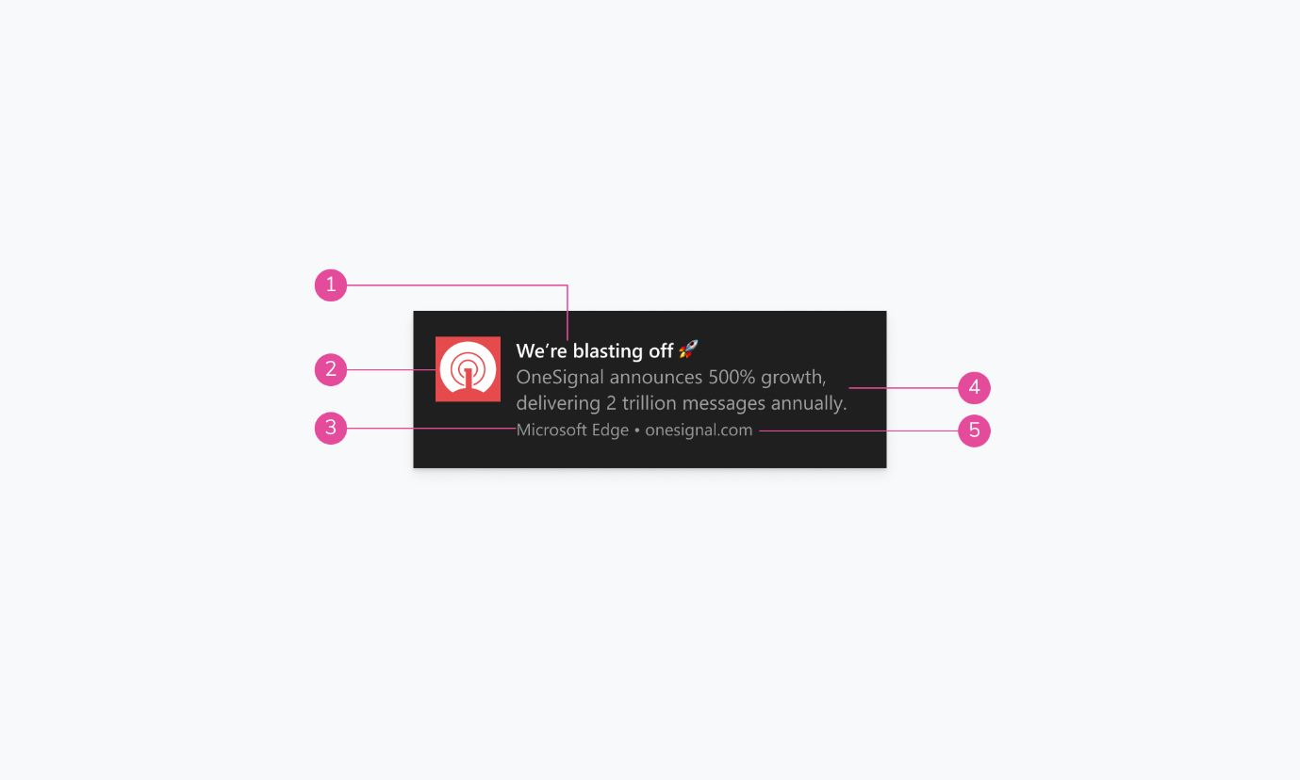

Figure 9. Edge push notification for Windows

**Title**  
Restricted to 40 characters.

1. **Icon**  
   192x192 or larger. PNG, JPG, GIF (not animated).
2. **Browser**  
   Can't be changed.
3. **Content**  
   Restricted to 140-190 characters.
4. **Domain**  
   Website user is subscribed to. Can’t be changed.

## Web Push, Chrome for Android 11

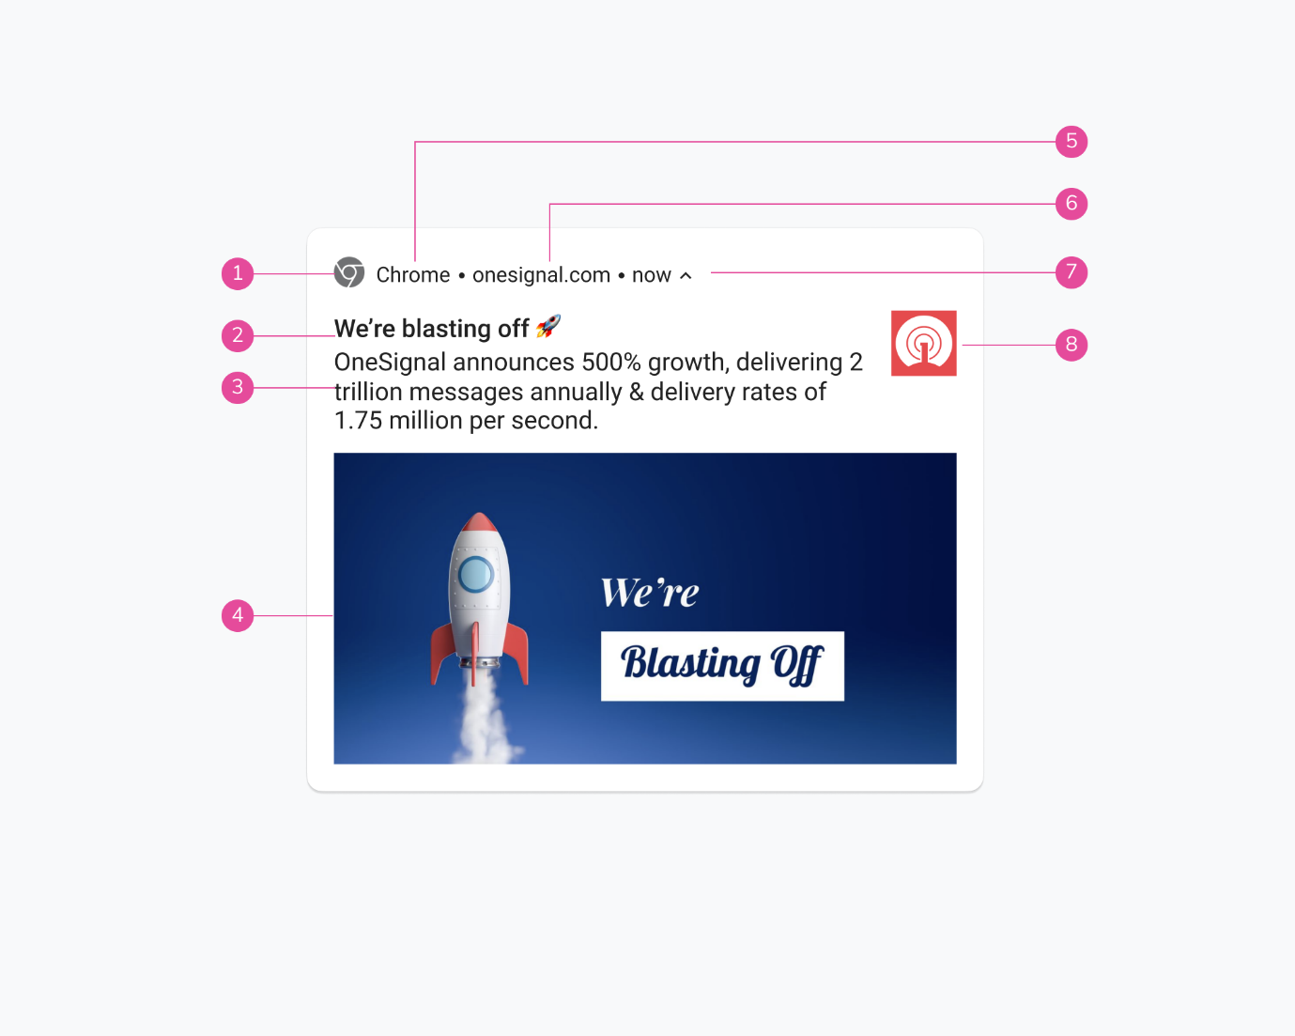

Figure 10. Chrome push notification for Android

**Badge**  
72x72 or larger. Must be white with a transparent background. PNG.

1. **Title**  
   Restricted to 50 characters.
2. **Body**  
   Restricted to 150 characters.
3. **Large Picture**  
   1024x512 or 2:1 aspect ratio. PNG, JPG, GIF (not animated).
4. **Browser**  
   Can’t be changed.
5. **Domain**  
   Website user is subscribed to. Can’t be changed.
6. **Time Stamp**  
   When the message was received.
7. **Icon**  
   192x192 or larger. PNG, JPG, GIF (not animated).

## Mobile Push, Android 11 Native

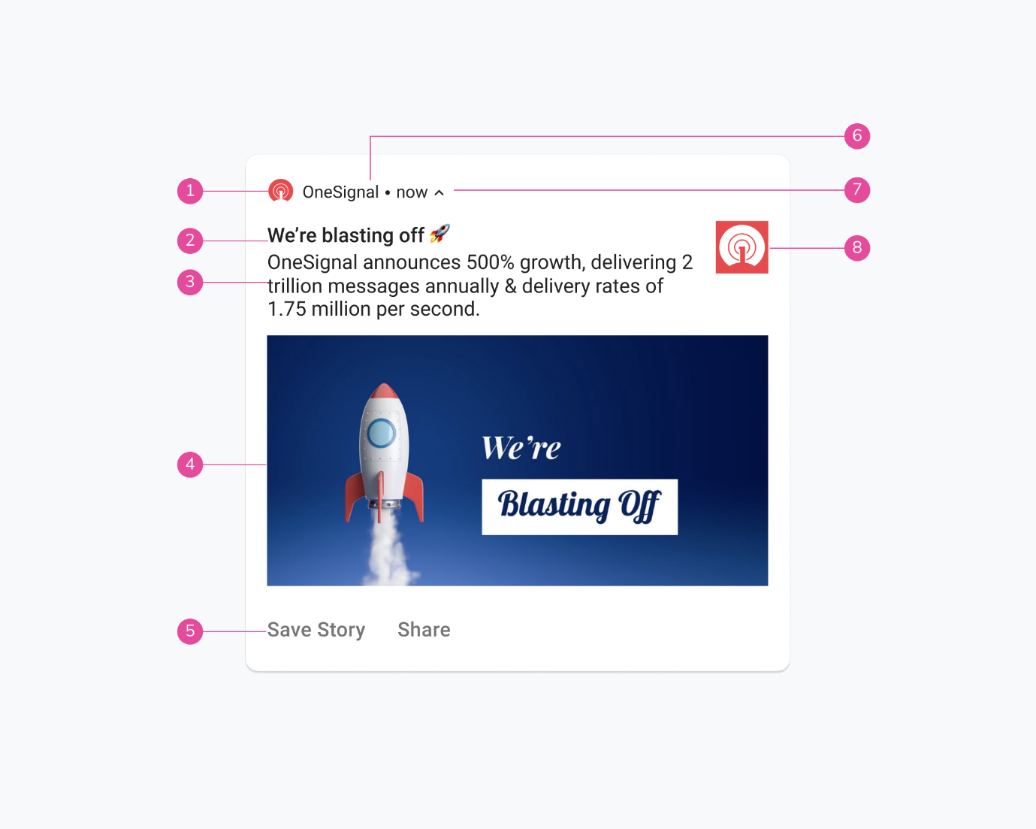

Figure 11. Native push notification for Android

**Small Icon**  
24x24 - 96x96 to fit all device sizes. Must be white with a transparent background. PNG.

1. **Title**  
   Restricted to 50 characters.
2. **Body**  
   Restricted to 150 characters.
3. **Large Picture**  
   1440x720 or 2:1 aspect ratio. PNG, JPG, GIF (not animated).
4. **Action Buttons**  
   Supports up to 3 buttons.
5. **App Name**  
   Can’t be changed.
6. **Time Stamp**  
   Time message received.
7. **Icon**  
   192x192 or larger. PNG, JPG, GIF (not animated).

## Mobile Push, iOS 14 Native

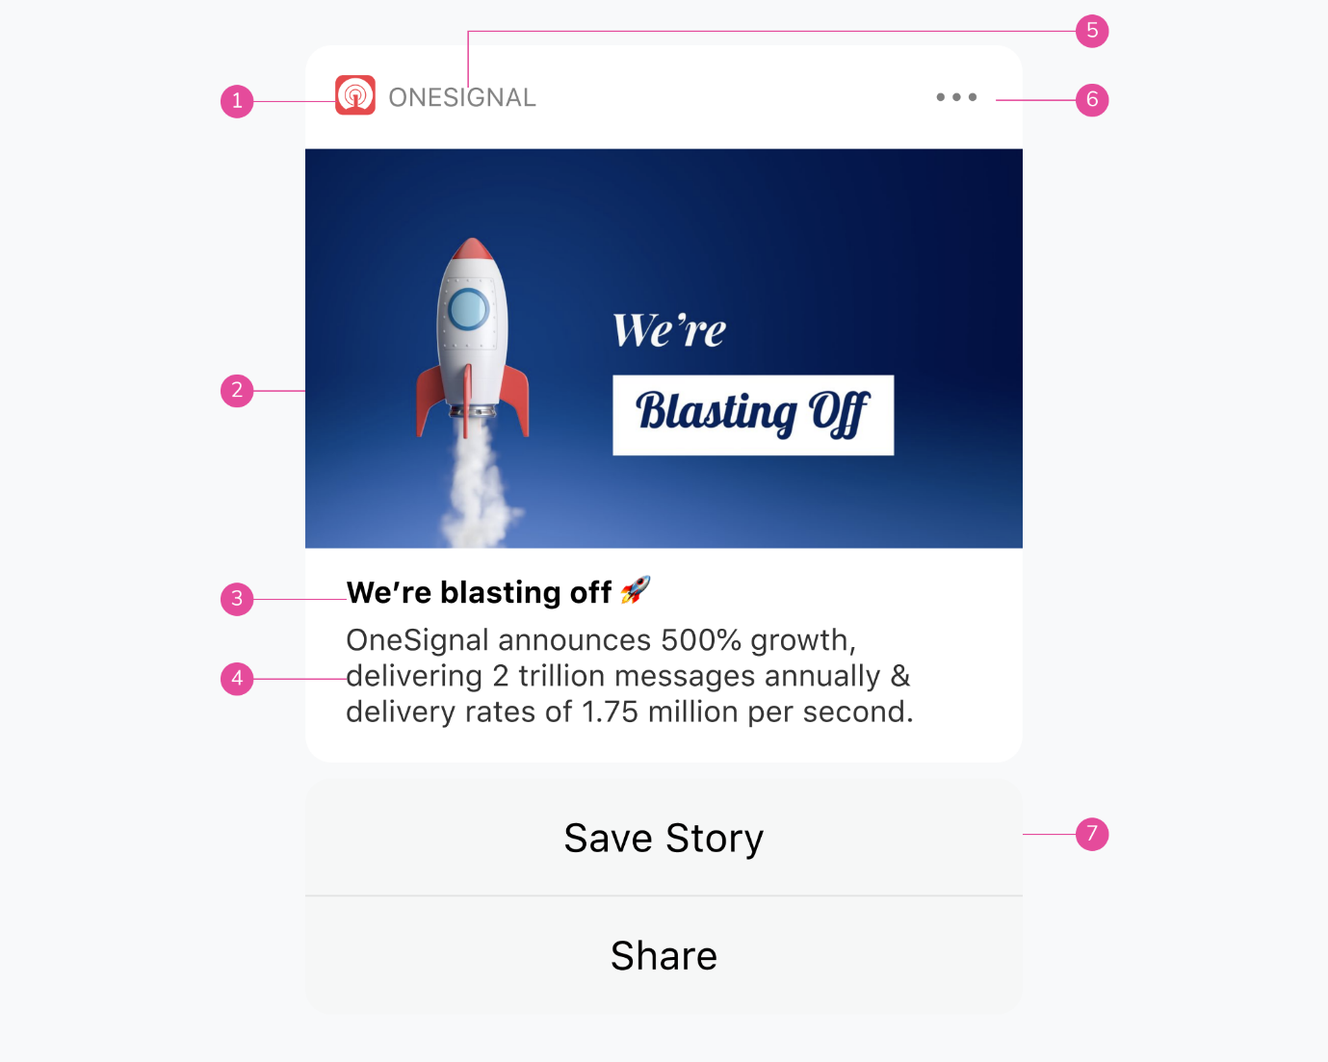

Figure 12. Native push notification for iOS

**App Icon**  
Uses the app's default icon and can’t be changed.

1. **Rich Media**  
   1024x1024 or 1:1 aspect ratio. PNG, JPG, GIF, MP4, MP3, WAV.
2. **Title**  
   Restricted to 25-50 characters.
3. **Message**  
   Restricted to 150 characters.
4. **App Name**  
   Can’t be changed.
5. **Options**  
   Can’t be changed.
6. **Action Buttons**  
   Supports up to 4 buttons.

iOS also has support for a subtitle. Note that unlike Android, iOS currently has no support for web push.